

Consultation On Proposal To Renew Selective Licensing

Harrow Council has identified areas where there are a number of badly managed and poorly maintained properties which are linked to anti social behaviour. To overcome these problems
Harrow Council is considering renewing the selective licensing scheme in a designated area, being the Edgware ward. Map is enclosed showing the roads affected.

Working in partnership with the Police, landlords, agents, tenants etc we aim to tackle anti-social behaviour and improve areas in low housing demand. We want to improve the area to make it attractive for people to want to live, work and invest in the area. Since Selective Licensing was introduced in Edgware we have:

- Licensed XX amount of premises
- Dd
- Dd
- Dd

If the Selective Licensing scheme is renewed, all private rented properties would be required to apply for a license. This will enable the Council to ensure that fire safety standards, basic amenities and general management of rented properties are being met. The Scheme will be reviewed and renewed after five years from date of implementation, and a proposed fee of £550.

The results of the consultation will enable the Council to ensure, through the renewal of the Selective Licensing scheme, to address your concerns. We will not give your personal information to anyone else. The information we receive helps us to see if the people who fill in our questionnaires reflect the different groups of people who live in the borough. Under the Data Protection Act 1998, we require your consent to process it. When you fill in the boxes below you are giving your consent.

An online version is available at http://www.harrow.gov.uk/environmentconsultations

SERVICE
A1 | Our services are open from 9am to 5pm Monday to Friday. How do you rate this availability? |  | Excellent, Good, OK, Poor,  Comments:
A2 | Is your business your  Own  Rented  Leased  Other |  | Yes No  Yes No  Yes No  Please specify:
A3 | What type of business do you run (please specify)  Food outlet  Newsagent  Bookmakers  Other |  | Yes No  Yes No  Yes No  Please specify
A4 | Would you invest further in the borough |  | Yes No Don’t Know  Comment
YOUR EXPERIENCE
B1 | Have you experienced any of the following problems with private rented properties?  Badly managed properties  Property condition in a poor state of disrepair  Overcrowded properties  Overflowing bins / fly tipping  Nuisance from anti-social behaviour  Groups congregating  Alcohol related crime  Drug dealing or drug related issues  Gang nuisance  Violence  Harassment  Racial prejudices  Other |  | Yes No  Yes No  Yes No  Yes No  Yes No  Yes No  Yes No  Yes No  Yes No  Yes No  Yes No  Yes No  Comment
B2 | Has your business being affected by  Noise nuisance  Nuisance from parking  Noise from cars  Nuisance neighbours  Overflowing bins/fly tipping  Drug/alcohol related crime  Other |  | Yes No  Yes No  Yes No  Yes No  Yes No  Yes No  Comment
B3 | Do you agree that Harrow Council should hold Landlords and Managing Agents responsible to manage their properties? |  | Yes No Don’t Know  Comments
B4 | Do you think that landlords are taking enough action against tenants who cause a nuisance or anti-social behaviour |  | Yes No Don’t Know  Comments
B5 | Do you think the Council is dealing effectively with landlords and agents who neglect their properties |  | Yes No Don’t Know  Comments
B6 | Selective licensing scheme would enable the Council to have greater control on private rented properties. Therefore do you agree that Harrow Council should introduce selective licensing scheme? |  | Yes No Don’t Know  Comments
B7 | Do you feel anti social problems are dealt effectively  By the Council  Police  Partnership working with Landlords/Managing agents |  | Yes No  Yes No  Yes No  Comment

OVERALL SATISFACTION
C1 | What is your overall opinion of our service? | Excellent, Good, OK, Poor,  Comments:
C2 | Are there any other aspects you wish to comment on? | Yes No  Comments:
C3 | Is there anything else, which you feel, is important for the service or would improve the service? | Suggestions:  1 ………………………………………………….  2 ………………………………………………….  3 ………………………………………………….

FURTHER CONSULTATION
D1 | Would you be interested in participating in future stakeholder consultation exercises regarding the review of the Council’s Private Sector Housing Enforcement policies? | Yes No  Comments
D2 | You are welcome to return this questionnaire anonymously, but if you wish to give your name and address so we can respond to any issues you have raised, then please do so here. | Name:  Address:  Tel:  Email:

CUSTOMER SATISFACTION SURVEY
To help us monitor equal access and service delivery, we would like to monitor the ethnic origin of our service users. This will help us to ensure that we continue to provide a service, which is delivered on a fair basis across the community. Any information you provide will be treated in strictest confidence.

Please tick the box which best describes your ethnic origin:
Black African
Caribbean
Other Please specify ………………….…………………

Asian Bangladeshi
Chinese
Indian
Pakistani
Other Please specify ………………….…………………

European Irish
UK
Other Please specify ………………….…………………

Other Ethnic Group Please specify ………………….…………………

Is your first language English? Yes
No If “NO” please specify ………….…………………

Gender Male
Female

Thank you for taking the time to complete this form and assisting us in improving the service. Your comments and suggestions are always welcome.

Please return the completed questionnaire to:
Residential Licensing Team
Community & Public Protection
Civic Centre
PO Box 18
Station Road
Harrow
HA1 2UT Email: residential.licensing@harrow.gov.uk
If you have any questions regarding this form, please do not hesitate to contact Residential Licensing Team on the above email

Map of proposed ward

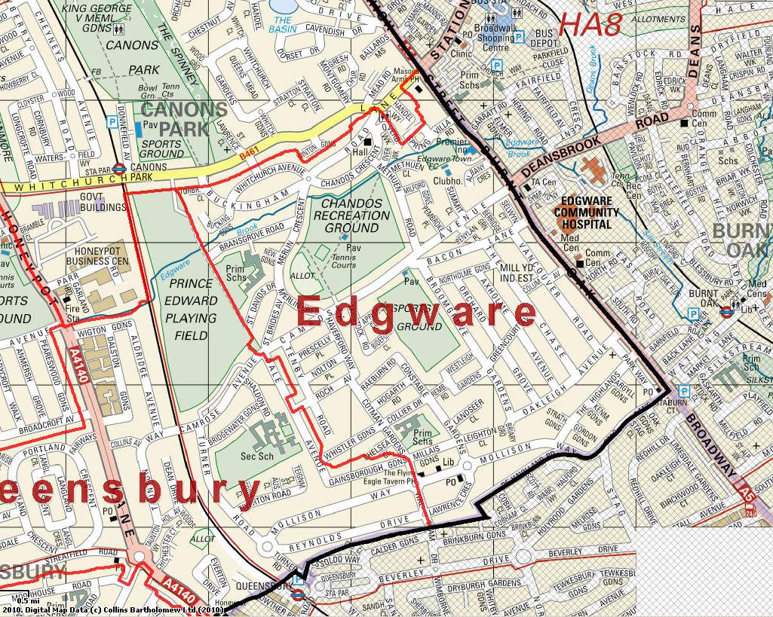

Designated ward road names:

All Roads within the Ward of Edgware being:
Lawrence Crescent Gordon Gardens Mollison Way De Havilland Road
Strathclyde Gardens The Highlands Kenmore Gardens Argyll Gardens
Parkway Leighton Close Constable Gardens Millais Gardens
Chelsea Close Cotman Gardens Collier Drive Hogarth Road
Raeburn Road Rembrandt Road Westleigh Gardens Broomgrove Gardens
Greencourt Avenue Orchard Grove Axholme Avenue The Chase
Vancouver Road Columbus Avenue Bacon Lane Camrose Avenue
Rochdale Avenue Nolton Place Prescelly Place Tenby Road
Haverford Way Tavistock Road Appledore Close Bideford Close
Northolme Gardens Penylan Place Selwyn Court Berridge Green
Pembroke Place Summit Close Albany Crescent Milford Gardens
Methuen Road St Brides Avenue Merlin Crescent St David Drive
New Gardens Bransgrove Road Buckingham Road Chandos Crescent
Methuen Close Spring Villa Road Overbrook Walk Whistlar Gardens
Buckingham Gardens Torbridge Close Burnt Oak Broadway Waltham Drive
Oakleigh Avenue Landseer Close Whitchurch Avenue Overbrook Walk

Edgware Ward Councillors



